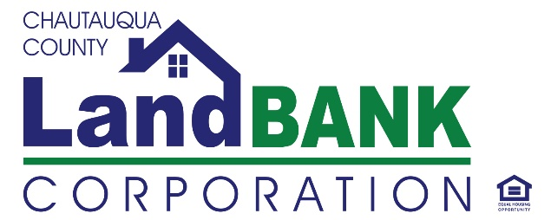

REQUEST FOR QUALIFICATIONS (RFQ)
Demolition Project Management

The Chautauqua County Land Bank Corporation (“Land Bank”) is seeking statements of qualifications from project managers/firms to provide professional oversight and management of its demolition services program. The Land Bank funds primarily residential, and some commercial demolitions through-out the county, in support of local municipal needs to remove abandoned, and derelict properties from their communities.
Funding is estimated to accommodate 30-40 demolitions per year, with the first funding cycle anticipated to be May 2023- December, 2024. Project Management would include coordination of environmental assessments, bid procurement, vendor management and compliance, site documentation/review, accounting/budgeting, workflow management and data services. All work must comply with state, local and Land Bank regulations and policies. Contracted manager would report directly to the Land Bank’s Executive Director.
Consultants who wish to be considered for this contract should provide their statements of qualifications via email to gparadis@chautauqualandbank.org by COB, April 15, 2023. Statements of Qualifications must include at a minimum:
- Statement of Interest
- Copy of current licenses, certifications, resume
- Current hourly rate
- List of references with current address and telephone numbers for recent projects of a similar nature.
Selection will be based on the following criteria:
- Project Manager’s qualifications, relevant experience, and availability
- Key project team members’ qualifications, relevant experience, and availability
- Firms’ (Prime and Subs) relevant experience
- Ability to respond to project needs and requirements
- Past performance.

