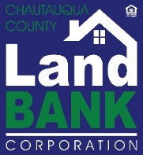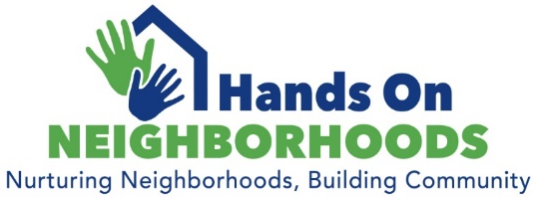

Dear Community Partner:
Be a part of something special!

Hands On Neighborhoods is an initiative by the Chautauqua County Land Bank (CCLBC) to foster community pride and build relationships. Its mission is to empower community members in building pride in place; to leverage resources, and work together towards strengthening their neighborhoods while building community, both on their block, and through-out the city.

When we launched Hands On Neighborhoods Jamestown in 2021, we worked diligently with our partners to host 7 cleanups in 7 neighborhoods over the course of 7 months. This year, we are working towards passing the torch to the City of Jamestown and are aiming to function more in a support capacity, as the program was successful and had gained momentum there. This will allow us to continue to roll out new Hand On Neighborhoods initiatives throughout the county moving forward.

We are proud to announce that we will be hosting Hands On Neighborhoods Dunkirk in 2022! It is a collaboration between CCLBC and the City of Dunkirk, Revitalize Dunkirk, and many more. The goal in year 1 is to host two community clean up events that convene community members from various sectors and neighborhoods, provide networking opportunities, and provide housing-related information and resources.

We will be engaging community members, civic organizations, church groups, affinity groups and businesses to work alongside us, cleaning up the streets and learning about city and housing resources. The clean-ups will be followed up with other components of our Hands On Neighborhoods program, including workshops, a Home Ownership Fair, a home ownership mentoring program, and more! A tool kit has been created to guide grassroots efforts to host their own neighborhood events. We want to create a sustainable way to continue these initiatives in communities across the county.

Won’t you join us in making this program a success?
We are looking for support through program sponsors, donations and volunteers. Sponsorship allows us to purchase equipment and supplies (litter grabbers, garbage bags, PPE, etc.), provide equipment to get the job done (dumpster rental, etc.), refreshments on event days, and promotional activities/materials to spread the word. For more details on the program and sponsorship opportunities, please refer to the following pages.

Please consider lending your support and help us make Hands On Neighborhoods a successful county-wide program! We look forward to working with you to create a mutually beneficial partnership. If you have any questions, please reach out to me directly at 716-969-7843 or gparadis@chautauqualandbank.org.

Thank you for your consideration.
Gina Paradis
Gina C. Paradis
Executive Director

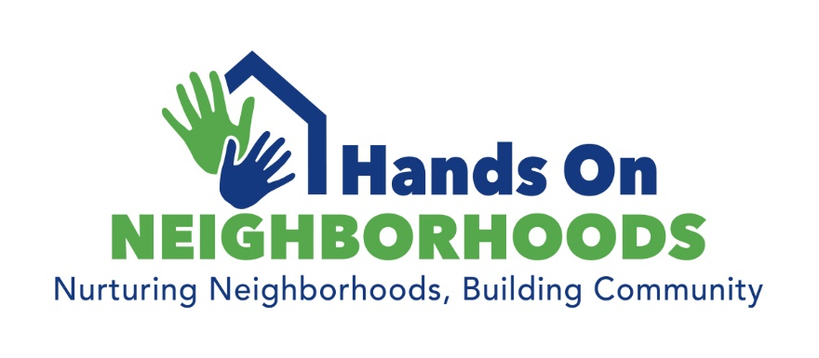
2022 Sponsor Opportunities

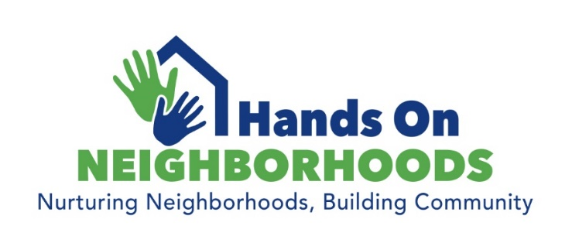

Mission:
Empower citizens in community-building; build a sense of pride in place; educate them in leveraging resources; and work together towards strengthening neighborhoods while building community, both on the block, and through-out the city.
Overview:
It is not only about hosting clean-up events, but using such events to engage residents in working together, and building relationships with their neighbors, their community leaders and local organizations. It is about empowering community members to take action to create better living environments at a neighborhood and community level. The program will focus on litter removal, neighborhood safety, and healthy housing. We have been working to produce a “tool kit” resource guide to assist grass roots efforts in taking the lead for their own neighborhood initiatives, and will be expanding the program in the coming year to provide workshops in various homeownership subject areas, host an annual Housing Fair, and create a mentoring program for first time homebuyers. The program will also incorporate a CPTED program (Crime Prevention Through Environmental Design) that is being developed here locally with law enforcement and county planners currently undergoing the proper training. Eventually, we also hope to initiate a mobile tool lending library.
Sponsorship:
Sponsorship can take the form of cash or a combination of cash and in-kind product or services. We are always in need of supplies for both promotional and event-day activities. This includes: printing, copies, t-shirts, PPE, rakes, brooms, garbage bags, bottled water, snacks/refreshments, etc.
Program Partner: $3,000-$5,000
As an Official Program Partner, you will receive recognition as the official partner of Hands On Neighborhoods, including featured placement in all event promotional materials, event signage at each event, press releases, etc. You will receive a highlighted presence on the CCLBC website on all Hands On Neighborhoods informational and promotional pages, including logo, listing and link. Additional exposure on all social media platforms, including mutually agreed upon dedicated posts monthly, as well as mention as featured partner. We will work with you to create a specific product giveaway as it relates to your business, recognition of any donated product, mentions in PSAs at events, and featured logo placement on all materials produced for the program, including T-shirts, collateral materials, signage, etc.

Event Sponsor: $1,000
Receive sponsor recognition on all event promotional materials, including event signage. You will receive recognition on Hands On Neighborhoods informational and promotional pages on the CCLBC website, including logo, listing and link. Receive inclusion in social media partner posts, and four dedicated posts. Mention in press releases, and logo mention on promotional materials, any specific product/giveaway related promotion, recognition of any donated product, as well as logo placement on T-shirts.

Neighborhood Sponsor: $500
Listing and link on CCLBC Hands On web page, two dedicated posts on social media, and mention in partner posts. Mention in press releases, any specific product/giveaway related promotion, recognition of any donated product, plus signage at 2 neighborhood events.

Good Neighbor Sponsor: $250
Listing on our website sponsor page, one dedicated post on social media, mention in partner posts, recognition of any donated product, and any specific product/giveaway related promotion.

Sponsorship and Donation Commitments may be made online at https://CHQLandbank.org/HandsOn or by check to:
Chautauqua County Land Bank Corporation
P.O. Box 603
Fredonia, NY 14063

Additional Ways You Can Help:
We need volunteers!
Please consider volunteering. We always welcome volunteers and are looking for volunteers for the following roles: Program Planning Committee, Program Ambassador, Sponsor Committee.
Or, come out and volunteer at a clean-up event. Participate individually or organize your friends and volunteer as part of a team.
CORPORATE/NON-PROFIT/CHURCH/SCHOOL/AFFINITY GROUPS – Show your commitment to the community by volunteering as a group for the clean-up events. Pre-register your team and your work will be highlighted in our event coverage!
Donate. If you are unable to make it an event, please consider donating. Donations are always appreciated. If you can, please help secure donations—share with your friends and colleagues that you think might be interested in this community initiative.
More about the Chautauqua County Land Bank:
The Chautauqua County Land Bank Corporation is a non-profit organization that operates as a local public authority to assist communities throughout the county deal with problem real estate and blight due to vacancy, abandonment and foreclosure. The CCLBC has rehab and demolition programs, as well as vacant lot, healthy housing and neighborhood revitalization programming. We have a Board of 11 members from across the county, who meet monthly to help shape the programming and vision of the organization, and to guide the operations, and make decisions on acquisition and disposition of property.

