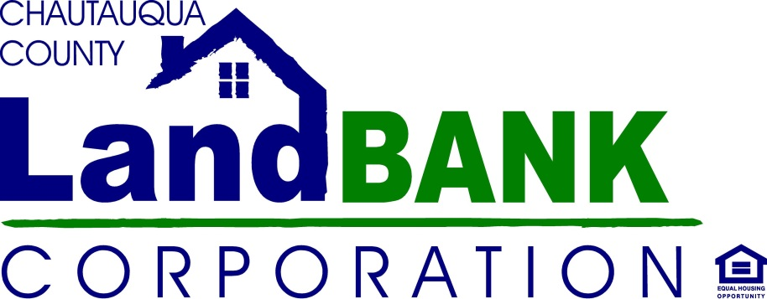
NEGOTIATED SALES PROGRAM
Purchaser/Developer Application

Date:

Name, Address, City, State, Zip, phone number, email address

Address of Property(ies) Interested In: __________________________________________________

Realtor Name/Agency (if engaged)______________________________________________________
Realtor Contact Info: _________________________________________________________________
Project Description (what are your plans for renovation/rehab/occupancy):

Tell us a little about yourself and your experience with this type of project:

End Use Ownership: (Rental/Re-Sale/Owner Occupied, etc.):

Proposed Construction:

Purchase Offer: $ ________________________________

Preliminary Renovation Budget: $_________________________________________________
(Please attach detail; a break down by construction materials or project area would be best)

Proposed Timeline: ______________________________________________________________________________________________________

Can you complete the project in 12 months from your start date? Yes No (circle one)

If not, when is your targeted End Date? _________________________

I hereby submit this proposal for consideration, and acknowledge the Land Bank’s right of acceptance, negotiation or rejection of it, based on their stated policies, mission and/or objectives. I certify that I have read and understand all of the Chautauqua County Land Bank’s Sales guidelines, including the Acquisition/Disposition policies and Developer Selection Criteria, and my questions were sufficiently answered by a Land Bank representative.

________________________________________ ____________________________________
Signature Name
____________________________________
Date

