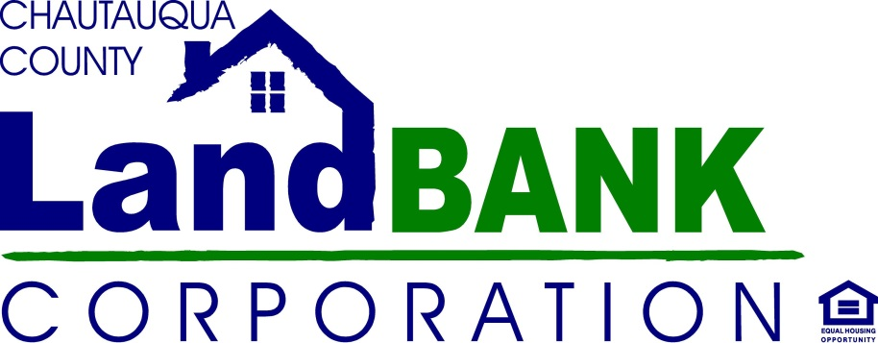
SALES 4 REHAB PROGRAM
Purchaser/Developer Application
Commercial Property

Date:

Name, Address, City, State, Zip, phone number, email address

Address of Property(ies) Interested In: ___________________________________________________

Section, Block & Lot #:________________________________________________________________
Realtor Name/Agency (if engaged)______________________________________________________
Realtor Contact Info: _________________________________________________________________
Project Description- Please describe in as much detail as possible, your plans for renovation/occupancy and business operation:

Do you have a Business Plan for this Project?
Tell us a little about yourself and your experience with this type of commercial project (Any additional documentation regarding your experience, qualifications, etc. will assist in your proposal consideration):

Please provide two references who can attest to your experience with this type of commercial renovation and/or venture (name/email/phone):
1.
2.
End Use Ownership: (Lease/Re-Sale/Owner Occupied, etc.) If Lease or re-sale, please let us know if the eventual buyer/lessee has been identified.

Proposed Construction/Rehab - Please be as detailed as possible with renovation plan:

Purchase Offer: $ ________________________________

Preliminary Renovation Budget: $_________________________________________________
Please attach detail; a break down by construction materials or project area would be best. Proposals without a detailed renovation budget will not be considered.

Financial Verification – How will this project/renovation be financed; what financial commitments are in place; what assistance or resources will you be requesting from the county or local municipality? (Please provide detail regarding sources and estimated amounts of financial support for the project)

Please provide 2 References for Financial Verification (name/phone/email):
1.
2.

Proposed Timeline:

I hereby submit this proposal for consideration, and acknowledge the Land Bank’s right of acceptance, negotiation or rejection of it, based on their stated policies, mission and/or objectives. I certify that I have read and understand all of the Chautauqua County Land Bank’s Sales guidelines, including the Acquisition/Disposition policies and Developer Selection Criteria, and my questions were sufficiently answered by a Land Bank representative.

________________________________________ ________________________________ ___________
Signature Name Date

