INVITATION

The Chautauqua County Land Bank Corporation (hereinafter called “CCLBC”) is pleased to invite proposals for the redevelopment of a 3.6 acre parcel (“Site”) on the Lake Erie waterfront in Silver Creek, New York. The CCLBC is seeking proposals and evidence of capacity from qualified developers with the vision, resources and expertise to develop the Site. Plans for this development envision a public-private use including pedestrian access to the lake and amenities, in addition to either leased or owned residential units. Other approved uses or amenities may include food and beverage outlet(s), and/or recreational outlets.
Please refer to the Conceptual Site Plan attached hereto as Exhibit 1.
This Request for Proposals (hereinafter called “RFP”) is the first step in a three-phased process, described as follows:
- All proposals will be reviewed and a shortlist of no more than three (3) prospective developers will be selected.
- The shortlisted developers will each have an in-person interview and Q&A session.
- CCLBC will select and begin exclusive negotiations with the developer who best matches the desired vision and qualifications for the project.
Responses to the RFP must be received by March 21, 2020
EMAIL RFP RESPONSES TO: BurnsL@co.chautauqua.ny.us

CHAUTAUQUA COUNTY LAND BANK CORPORATION
The property is currently owned by the Chautauqua County Land Bank Corporation (hereinafter called “CCLBC”). The CCLBC is a Not-For-Profit (501) (c)( 3) corporation, formed to combat community deterioration by facilitating the return of vacant, abandoned and foreclosed homes to productive use in order to eliminate the harms and liabilities caused by such properties, lessen the burden of local government, and act in the public interest.
The CCLBC has all the powers and duties as granted and governed by the following legislation:
- Article 16 of the Not-for-Profit Corporation Law of New York State;
- Public Authorities Law of New York State.

The stated Mission of the CCLBC is to “Control and manage strategically selected dilapidated and abandoned residential and commercial properties acquired through the County tax foreclosure process, bank foreclosures and/or donations, and facilitate solutions aimed at stabilizing neighborhoods, encouraging private investment, and improving the quality of life throughout Chautauqua County.”

Additional Information about the CCLBC and its programs is available at https://CHQlandbank.org.

LOCATION OVERVIEW
Silver Creek is a village located in the town of Hanover, County of Chautauqua, State of New York, United States.
As of the 2010 census, the Village had a population of 2,656. Silver Creek is named after a small river which runs through the Village, and it is located on the shore of Lake Erie.
The community was first settled around 1803, and the first schoolhouse was erected around 1823. The Village of Silver Creek was incorporated in 1848, and was an important port on Lake Erie until railroads reduced shipping. The Village is home to a skew arch railroad bridge, one of the few bridges in the country built on an angle.
Silver Creek is part of the Lake Erie Basin. The two creeks in the Village, Silver Creek and Walnut Creek, drain into the lake. Silver Creek is at the junction of New York State Route 5 (Central Avenue) and US Route 20 (Main Street), north of New York State Thruway (Interstate 90) Exit 58.
Silver Creek is approximately 35 minutes from downtown Buffalo, New York; 15 minutes from the city of Dunkirk, New York; and an hour from Erie, Pennsylvania. Sunset Bay and Hanover Bay, popular summer vacation communities on Lake Erie, are less than 10 minutes from the Site.

Location Map
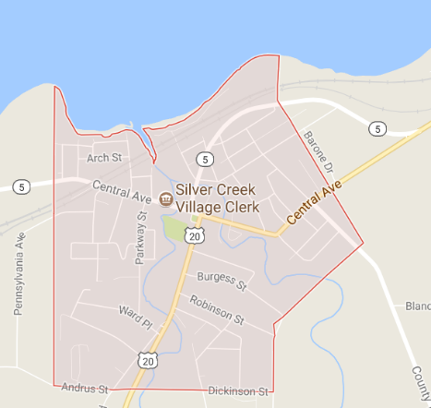
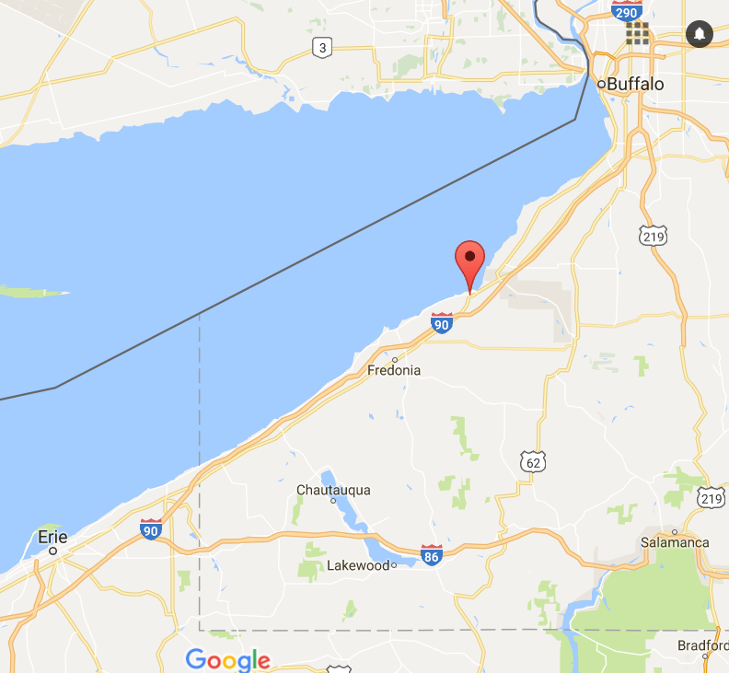

Site Description
This 3.6 acre parcel, located at 42 Lake Avenue, in the Village of Silver Creek, N.Y. is located on the shores of Lake Erie with approximately 675’ of lake frontage and approximately 400’ of frontage on Walnut Creek. The site is zoned commercial¹ for ease of development.
The parcel is located on a picturesque, secluded beach with natural barriers on three sides. The northern parcel line is Lake Erie; the eastern parcel boundary is slightly wooded and abuts a residential property; the southern parcel line abuts a sizeable, historic but active railroad berm and trestle; and the western parcel line is Walnut Creek. The Site is accessed by a private driveway connected to Lake Avenue and is zoned commercial for ease of re-development. Wetlands, a flood plain, and coastal hazard area considerations exist on the Site. Please see the supplemental survey for more information. Due to the Coastal Erosion Hazard Area boundary, the development footprint represents 1.3 acres, unless a variance is applied for though the DEC Region 9.
Please refer to the Survey attached hereto as Exhibit 2
DEVELOPMENT OPPORTUNITY
The Site’s central location to the NYS Thruway at Exit 58 at the Eastern gateway to Chautauqua County, accented by the natural beauty of its secluded waterfront setting, makes it a most desirable parcel for both residential and leisure use. The proximity to Buffalo and Dunkirk also provide an easy commute to work, shopping, and other attractions in the nearby regions. Already a popular tourist and weekend leisure destination, Chautauqua County draws significant visitor traffic from a wide demographic with interests ranging from recreation to history, wineries to spiritualism. The quality of life, the access to the arts, outdoor recreation, quality schools, and village life attracts many seasonal and year-round residents, especially those seeking waterfront property outside the metropolitan area.
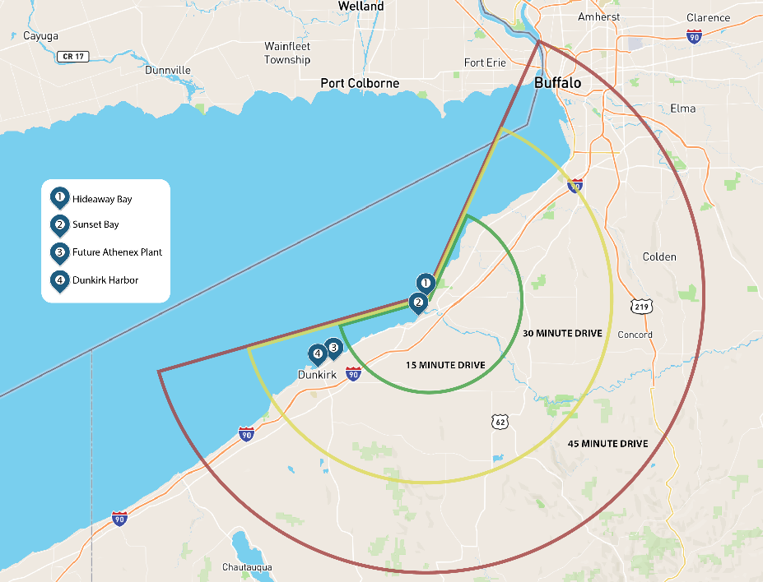
The Northern Chautauqua County region has committed to many initiatives that will facilitate public and private investment into its communities and enhance the economic vitality of the region. Among those initiatives are the Northern Chautauqua Local Waterfront Redevelopment Plan, the Regional Water District, and several Main Street Redevelopment Programs, which will each have defined public-private projects and support. The addition of a significant employer in the Athenex plant situated just 15 minutes away in the Town of Dunkirk, where 900 jobs will be added to the Northern Chautauqua County economy, represents an opportunity for increased demand for turn-key housing and amenities in the immediate area. Initial indicators from the company suggest that the demographic for recruited/relocating employees will be a younger, more affluent set who are more interested in move-in ready, rather than fixer-upper accommodations. This demographic is also looking for abundant recreational activities, access to arts and culture, and dining and entertainment options. A multi-million dollar refrigeration/warehousing development project is well underway, and Fieldbrook Foods, also located in Dunkirk, is investing in a $87 million expansion that will result in another 50-60 new jobs. These economic development successes are representative of the many developments tipping the scales for Chautauqua County, and this unique waterfront parcel provides an excellent opportunity for the right developer to secure a place in the vibrant future of this region.

SUBMITTAL REQUIREMENTS
Summary
The response format requested by the CCLBC is detailed in the following sections of this RFP. The submission of a concise, professional, and complete response will help the CCLBC identify the most qualified development teams who are most aligned with the stakeholders’ vision for the redevelopment of the Site, and will be indicative of the level of the respondent’s commitment to the desired project.
Any questions that arise during the preparation of a submittal should be addressed to Linda Burns, Chautauqua County IDA at burnsl@co.chautauqua.ny.us., or Gina Paradis, CCLBC Executive Director at gparadis@CHQlandbank.org. Respondents must demonstrate the experience, resources, and expertise needed to design, finance, develop and otherwise operate a successful project.
Respondents are asked to submit their proposals via email only, in PDF format, to burnsl@co.chautauqua.ny.us Proposals must be received no later than March 21, 2020 at 5:00 PM EDT.

Proposal Components
Transmittal Letter
The submission must include a transmittal letter, on official letterhead, that provides contact information for the person with authority to negotiate on behalf of the development team. The letter must also include an affirmative statement that the respondent agrees to the minimum business terms identified in the RFP. The respondent must certify that the RFP response and all exhibits are true and correct. Unsigned and/or undated submissions will not be accepted.
Development Team
Identify the developer and other key members of the development team, including the project leader for day-to-day management and the key consultants who will be responsible for implementing said project. Provide a succinct narrative describing the role and relevant expertise of each of the firms and key individuals who would be involved in the project’s implementation, with a current phone number for each.
Proposed Conceptual Development Scope
Provide a one-page narrative that describes the development concept that is envisioned for the Site. As part of that description, identify any responsibilities to be imposed on the Village, County, and/or CCLBC. At the respondent’s discretion, graphics, such as a conceptual site plan, and/or architectural drawings may also be provided.
Experience
Provide descriptions and references for at least one, but no more than three, projects that the respondent has undertaken that are comparable to the size/scope of the project being proposed for the Site. Each description should include the following information: project location, description, financing overview, and municipal reference.
Financial Capacity
Provide verifiable evidence of the development team’s financial ability to undertake and successfully complete the proposed project. This may include financial statements, annual reports, Letters of Credit, etc.
THE CCLBC recognizes the sensitive nature of financial capacity information requested in this RFP. Therefore, respondents may choose to provide a secure download site address link to share access with the CCLBC.
Required forms and Certificates
Please see Appendix A for required forms and certificates below:
- W-9
- CCLBC Vendor Form
- Developer Points of Contact Form
SELECTION PROCESS AND SITE EVALUATION CRITERIA
Selection Process
The selection process will be divided into the following 3 phases:
- All proposals will be reviewed and a shortlist of no more than three (3) prospective developers will be selected.
- The shortlisted developers will each have an in-person interview and Q&A session.
- CCLBC will select and begin exclusive negotiations with the developer who best matches the desired vision and qualifications for the project.
Evaluation Criteria
The following evaluation criteria will be used to evaluate the proposals:
- The developer or development team’s proven experience (and references) in successful financing, design, construction, and operation of projects of similar scope and scale.
- Financial capacity to undertake a project of the proposed magnitude.
- Overall quality of the proposed development and reputation of the developer/development team.
- Quality and completeness of proposal.

DECLARATIONS AND ADDITIONAL INFORMATION
The CCLBC Rights Pertinent to this Solicitation
- The CCLBC reserves the right to reject all submittals for any legal permissible reason without indicating reasons for rejection.
- The CCLBC reserves the right to amend this RFP by Addendum. The CCLBC is bound only by what is expressly stated in the RFP and any authorized written addenda to be posted on the CCLBC website.
- The CCLBC accepts no financial responsibility for any costs incurred by the respondent during any phase of the selection process. All submittals shall become the property of the CCLBC (except those materials marked “CONFIDENTIAL”) and may be used in any way deemed appropriate.
Withdrawal of Solicitation
The CCLBC reserves the right to withdraw this RFP at any time without prior notice, and makes no representation that any agreement will be awarded to any respondent. Additionally, the CCLBC expressly reserves the right to postpone opening responses to this solicitation for its own convenience and/or to waive any informality or irregularity in the responses received.
Confidentiality
All submittals in response to this RFP are considered confidential until the CCLBC makes a selection, at which time the submittals will become public information and available to the public for review. However, financial capacity information of each submittal will be treated as confidential to the extent it may be withheld under applicable freedom of information law.
Examination of Solicitation
The respondent understands that the information provided in this RFP is intended solely to assist the respondent in preparing a submittal. To the best of the CCLBC’s knowledge, the information is accurate; however, the CCLBC does not warrant such accuracy, and any errors or omissions subsequently do not invalidate this RFP.
Conflict of Interest
Respondents must comply with the requirements imposed by all federal, state and local laws, including those pertaining to conflict of interest. All members of responding development teams must disclose any and all circumstances that could give rise to any potential conflict of interest or appearance thereof with its participation in the project, with the CCLBC and/or the village and/or the county, including any of their agents, representatives, and consultants.
Nondiscrimination Policy
The respondent shall not discriminate on the basis of race, gender, religion, national origin, ethnicity, sexual orientation, age, or disability in the solicitation, selection, hiring, or treatment of subcontractors, vendors, or suppliers. The respondent shall provide equal opportunity for subcontractors to participate in subcontracting opportunities. The respondent understands and agrees that violation of this clause shall be considered a material breach of contract and may result in contract termination or other sanctions.
Supplier Diversity
The CCLBC recognizes the importance of supplier diversity in its procurement practices. The CCLBC is committed to contracting with qualified suppliers from all parts of the business community for goods and services. By encouraging the participation of Small business Enterprises (“SBEs”), Minority Business Enterprises (“MBEs”), and Woman Business Enterprises (“WBEs”)( collectively “SMWBEs”) in the procurement process, the CCLBC strengthens contracting opportunities for SMWBEs. The CCLBC encourages respondents to ensure these opportunities are leveraged in their project teams.

Definition of Silver Creek Commercial Zone included in supplement.

