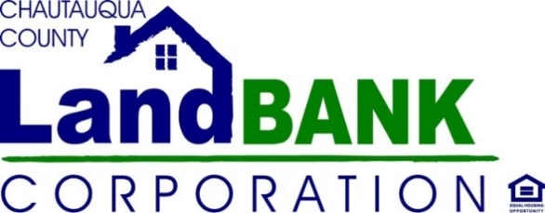

Monthly Board Meeting

April 19, 2023

Gerace Office Building, Room 331, Mayville NY

9:00 AM – 10:30 AM

**AGENDA**

1. Welcome/Introductions – Guests (J. Hemmer)
2. Privilege of the Floor (J. Hemmer)
3. Approval of Minutes – March 2023

(Attachment 1)

1. Property Disposition – Homes & Side Lots (anticipated as of 4/1/23)

35 Academy St., Westfield

47 E. 2d St., Dunkirk (side lot)

(Attachment 2, Resolution 04-19-23-02)

1. Financial Report (J. Cameron)

PARIS & Annual Report

(Attachment 3)

1. HR Manual/Policies Adoption (G. Paradis & D. Hannum)

(Attachment 4 & Resolution 04-19-23-03)

1. Prospective Board Member & Board Training Compliance (J. Hemmer)

(Attachment 5)

1. Program & Activity Updates (G. Paradis)
2. Other (G. Paradis, J. Hemmer)

Meeting Schedule: 5/10/23; 6/14/23; 7/12/23 - Mayville