Chautauqua County Land Bank Corporation
2020 Annual Report

Featured ReHab
TKO Properties, LLC
Chris Olsen & Tiffany Borst

This Jamestown home was acquired as a tax foreclosure in 2018 by the Land Bank. It had been vacant for several years.
The purchasers completed an upscale renovation with a modern open floor plan and upgraded appointments, while respecting and restoring the period details of the home
The home was recently sold to first-time homebuyers who will occupy the residence with their young family.

For more details on our Sales 4 Rehab program, visit our website:
https://chqlandbank.org

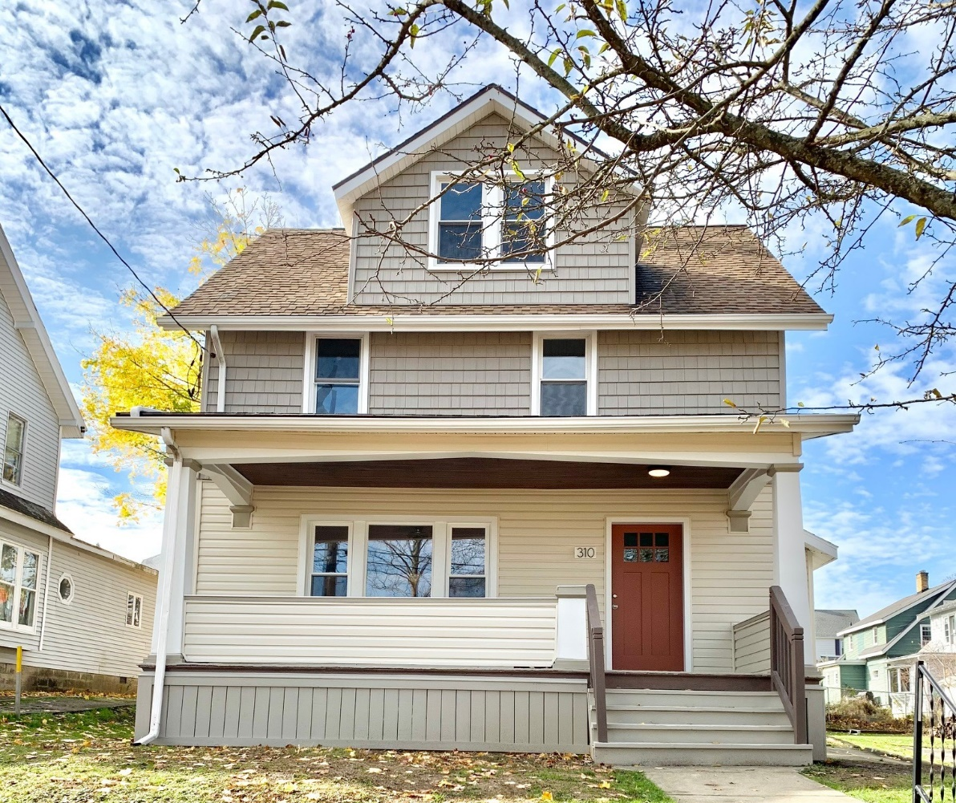
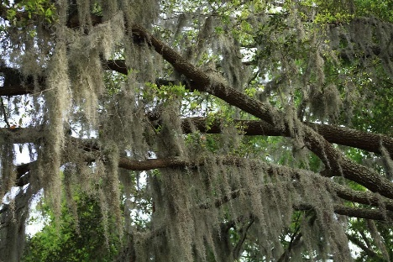
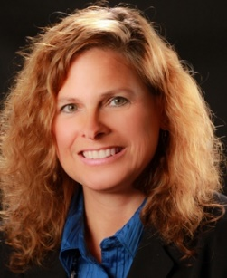

LETTER FROM THE EXECUTIVE DIRECTOR

2020 Annual Report
OK, so let’s address the elephant in the room… yes, the COVID-19 pandemic. Everyone is tired of hearing about it, but it hangs over all of us like the moss in a cypress forest; like stalagmites in a glacial cave…inevitable, menacing, an unescapable reality of the year past and the path forward.
Let’s face it, much of the last year was spent “coping”. Individuals and families struggled with fear, frustration, loneliness, insecurity, and worst of all, loss. It was no less challenging for our Land Bank and our partners and stakeholders, especially with work shut-downs and outbreaks, and overwhelming economic uncertainty. We were most mindful, however, of the devastating impacts that the pandemic had on families, especially the lower wage earners who lost their jobs, couldn’t pay their rent or mortgages, struggled to feed and/or educate their children. We also understood what the pandemic would inevitably portend for housing and commercial real estate issues in our community, and so we spent much of the year planning, and listening, and learning.
It is true that crisis can define us. It will test our mettle, our perseverance and resiliency. However, it can also provide clarity and purpose. By challenging our perspective, we dig a little deeper to define our priorities, we think more creatively to identify ways in which we might expand our reach and enhance our outcomes.
This past year that land bank has had to meet the economic and program delivery challenges with creativity and commitment. In an ever-changing environment, we worked with our partners to push our program objectives forward, and create new initiatives to assist hardest-hit neighborhoods and make our programs more accessible and equitable. To this end, we created two new programs:
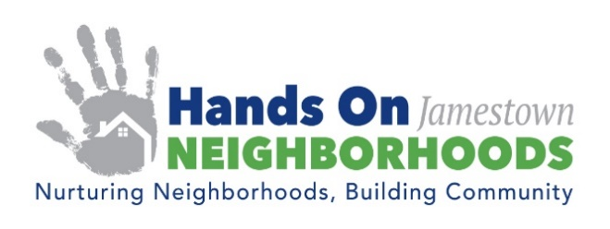
Hands On Neighborhoods will eventually be a county-wide initiative that will begin with a PILOT project in Jamestown, NY. There are three main program components to Hands On Neighborhoods:
- Neighborhood Clean Up Events
- Crime Prevention & Neighborhood Safety Enhancement
- Property Maintenance Mentoring & Mobile Tool Library
The objective of the Hands On Neighborhoods program is to empower community members to work together to create safer and healthier neighborhoods and improve the quality of life for all residents. We will be collaborating with residents, church and civic groups, businesses, municipal leaders, and public safety officials to breathe life into these programs and sustain them over time. As we develop each of the components of this program, we will also be creating a “tool box” so that grass roots efforts can be supported with materials, planning tools and marketing templates, enabling them to execute their own hyper-local events.
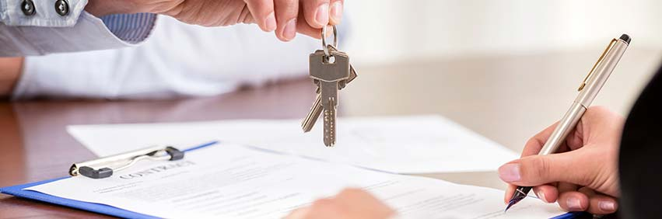
A Rehab Loan Fund is in the final stages of development, which will expand access to the CCLBC Sales 4 Rehab program to those of more limited financial means. The program will allow those who meet income and program criteria to secure mortgage loans that include funding for renovations of Land Bank properties. Most Land Bank properties do not qualify for conventional mortgages. Two homes, one in Dunkirk and one in Jamestown will be partially renovated and offered for sale through this program. This initiative is specifically intended to create equitable lending practices in neighborhoods and populations that have been underserved in the past, and will be marketed broadly across our diverse communities.
As we look forward to a return to some sense of normalcy later in 2021, the Chautauqua County Land Bank stands ready to collaborate with all of our public and private partners to address issues of vacancy, foreclosure crises, and equitable housing opportunity. We continue to identify opportunities to positively impact the quality of housing and residential life of our communities across Chautauqua County.
We wish to thank our partners, including Enterprise Community Partners, Inc., the New York State Attorney General’s office, the Chautauqua County Legislature, our local municipal leaders, county and local housing champions, and all of those individuals who have supported our efforts through their purchases, services, partnerships, and voices. Sharing our mission, expanding our reach, engaging more stakeholders as we tackle the housing and distressed property in Chautauqua County will continue to be our focus in 2021. We hope you will join us in helping to make our neighborhoods safe and strong, and providing healthy housing opportunities for all!
Humbly yours,
Gina Paradis
IN MEMORIUM
William Carlson
Founding Board Member

September 11, 2020 The Chautauqua County Land Bank Corporation lost our friend and fellow board member, Bill Carlson. Bill was a founding member of the Land Bank, an award-winning realtor/broker with Howard Hanna Holt Real Estate, a trusted advisor, and one of the most humble, genuine guys you could ever meet. His mischievous smile and easy charm belied his solid work ethic and ambition. Bill was a longtime volunteer fireman, Drum Corp member, avid traveler, and passionate Buffalo Bills fan. He was a committed father and partner to his fiancé Leslie, and continuously gave back to the community that he was so proud to call home. He was a generous soul always looking out for everyone and someone you knew who would always had your back. Bill was a valued member of our Board and a treasured friend who we will miss greatly, but we know that his spirit will continue to be present in all that we do for Chautauqua County.

Following are some of the highlights of our efforts over the past year:
Acquisitions & Dispositions:
Only one residential property was acquired in 2020, due to the moratorium on evictions and foreclosure proceedings constricting availability of vacant housing. Three additional parcels were acquired for demolition or post demolition for transfer to new adjacent owners.
18 Properties were sold. Of those, 15 were residential properties and three were vacant lots, representing $514,500 in assessment value returned to the county tax rolls, and $6,425,000 in private reinvestment, with $625,000 in residential rehabilitation, and an additional $5,800,000 in commercial/emergency housing projects.
ACQUISIONS 2020 DISPOSITIONS 2020
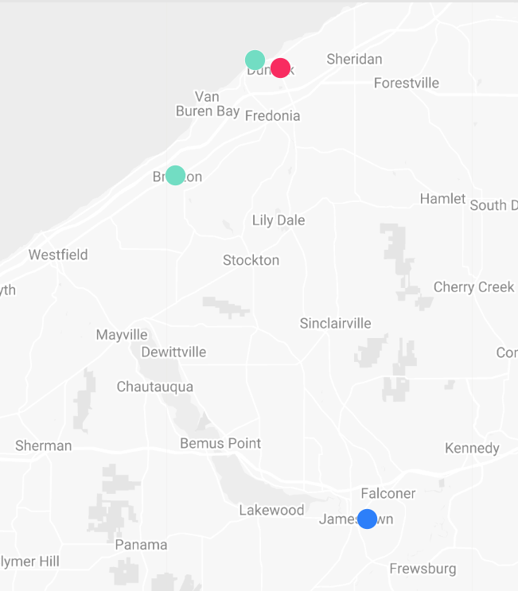
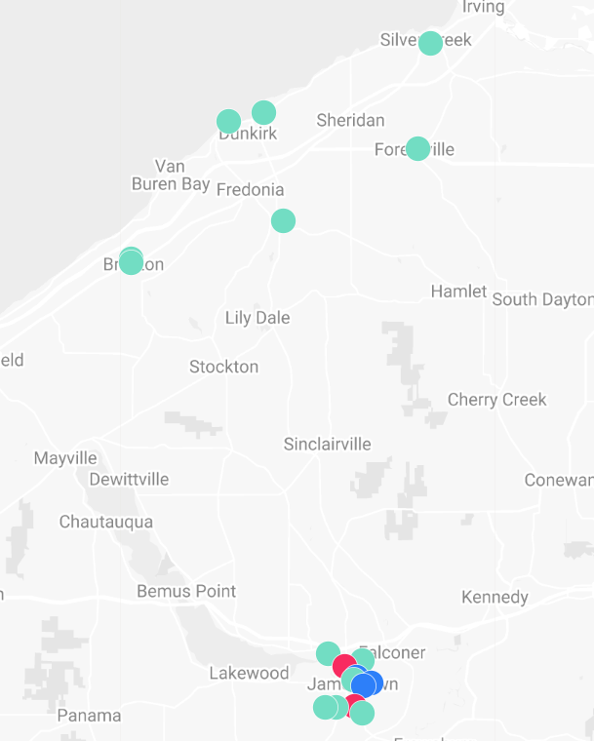
44 Babcock St., Silver Creek (Demo)
60 Point Dr. No., Dunkirk (REO-Rehab)
143 Lincoln, Dunkirk (Demo)
256 Willard St., Jamestown (Demo)

9562 Route 60, Fredonia
12 W 18th St, Jamestown
430 Hazzard St, Jamestown
84 Hotchkiss St, Jamestown
61 Point Drive North, Dunkirk
53 Arden Pkwy, Jamestown
44 Babcock Ave, Silver Creek
41 W Main St , Brocton
318 Lake Shore Dr E, Dunkirk
3041 Fluvanna Ave Ext Jamestown
24 Smith St & Lot, Brocton
239 Connecticut Ave, Jamestown
1797 Foote Ave Ext., Jamestown
13 Pearl St, Forestville
2087 Willard St. Ext., Jamestown (lot)
35 Tower St., Jamestown (lot)
11 Bush St., Jamestown (lot)
401 E. 5th St., Jamestown (donated for demo/redevelopment)

:

DEMOLITION Program:
$422,556 of our grant proceeds were spent on demolition across the county in 2020. Despite the “shelter in place” order, and multiple work site shut-downs due to COVID outbreaks, the Land Bank with the assistance of its partners Jamestown Urban Renewal Agency (JURA) and the City of Dunkirk, moved numerous derelict residential and commercial properties through the project pipeline to rid our cities and rural communities of blighted and unsafe properties.

OPERATIONS:
Grant Revenue bolstered our operations in 2020 with the addition of $51,000 in COVID related assistance, which reduced the burden of our administrative expenses during a year when property acquisitions were curtailed, and sales negatively impacted by the pandemic. Our Community Revitalization Initiative grant disbursements, provided the majority of our program funding, with disbursements of $639,443 in 2020. The balance of this funding will carry-through to the end of 2021. Real estate sales revenues bolstered our operations at just under $228,000; all but one of the properties sold was inventory acquired prior to 2020. By making the decision to invest a sum of $500,000 of our cash assets in a CD, the land bank generated over $7,000 in interest revenue.
Expenses directly related to property acquisition and holding costs, aka “Cost of Goods Sold” continues to be our largest expense, at 71% of our total expenses in 2020. Salaries (including payroll taxes) and Benefits, account for less than 19% of our budget, with overhead accounting for the balance, or 10%.
In examining the detail of Cost of Goods Sold, excluding the cost of demolition, the Land Bank’s largest expense in 2020 was real estate taxes. At just under $60,000, our annual tax payments assist the county with the revenue lost when they “make whole” the municipalities for tax delinquencies that resulted in foreclosures. Although the land bank is tax exempt upon acquisition, the organization made an agreement to pay the current year’s taxes on any property acquired from the county’s tax foreclosure auction. Construction draws at over $55,000 represent grant-funded rehab investments made to complete the Dunkirk Neighbor for Neighborhoods project, and a lead abatement project in Brocton. Acquisition costs account for approximately $47,000, which reflects the purchase of a bank-owned property (that the land Bank was able to re-sell at a healthy profit, to assist with our sustainability challenge) and Property Clean-out and Maintenance account for approximately $41,000 in annual expense.
As we track our revenues and expenses, we continually assess our operations and procedures, and identify opportunities to enhance our sustainability through controlling costs and improving profits.

