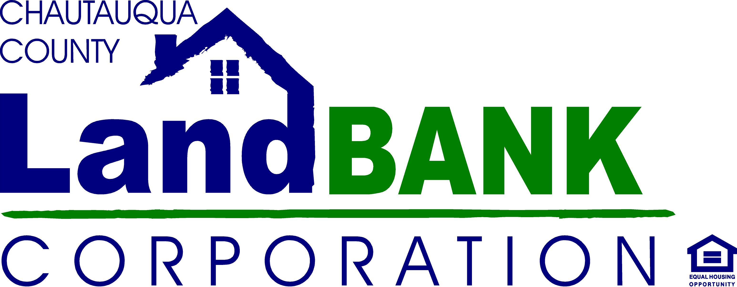

BOARD MEETING SUMMARY

DATE: March 10, 2021
LOCATION: Zoom

Attendees: Diane Hannum, Becky Meeder, Hugh Butler, Mark Geise, John Hemmer, Chuck Cornell, Paul Whitford, Nicole May
Excused: Lou Drago
Absent:
Staff: Gina Paradis, Allison Carrow (Legal Counsel); Jen Cameron
Guests: Shelly Lincoln, Ed Bysiek, Dennis Phillips
HIGHLIGHTS

1 | Diane H. opened the meeting at 9:00, and reviewed the agenda; Shelly Lincoln, a guest & resident of Cherry Creek introduced herself as a supporter of the Land Bank and thanked us again for all of the work we have done in Cherry Creek and around the county.
2 | Minutes from the February Meeting were tabled until next month.
3 | Audit – Ed Bysiek, CPA reviewed our annual audit. It was a clean audit with no deficiencies. The program’s financial standing is fairly consistent with last year, partially due to the assistance of grant funding secured through the pandemic. The Land Bank’s liquidity is currently very strong. Net assets are just shy of $1M or about $10k more than last year; this is primarily due to cost cutting measures on the expense side. Some discussion around the lingering Performance Escrows that were never claimed – could find no reference in Public Authority Law that said we need to turn over to the state. A couple of recommendations were made regarding timesheets for staff and completing the written personnel policies. Mark G. made a motion to approve the audit, seconded by Paul W. motion carried unanimously.
4 | Annual Meeting- The Board recessed the monthly meeting to move to the annual meeting agenda, with a motion by Mark G. seconded by Hugh B.:  - The Current Members of the Board did not require reappointment this year.  - Appointment of Members for Standing Committees – see Resolution; approved unanimously.  - Election of Officers – see Resolution; approved unanimously.  - Approval of Annual Report – see Resolution; approved unanimously.  - New Board members – two names were suggested, and the Executive Director authorized to check those persons interest and begin recruitment process.  - Annual Meeting adjourned to resume the Monthly meeting with motion by Paul W., seconded by Hugh B.
5 | Governance – Hugh B. reviewed the compliance status and Gina P. will follow-up on those lingering forms that have not yet been returned so that we can ensure we are in compliance with the March 30th deadline for the Code of Ethics and Sexual Harassment Training. The Financial Disclosure documents will be due by 4/30/21 directly to the county executive’s office.
7 | Administrative & Legal updates –The PARIS report has been completed and is ready for certification and submission. At this time, we do not yet know if there will be an auction in 2021 but the legislature is hopeful there may be one in Aug-Sept. Gina P. noted that there is a big push for federal legislation that will provide competitive funding sources for land banks. The NYS LBA is also continuing to pursue advocacy with NYS for dedicated funding.
7 | Meetings – to continue on Zoom until further notice. 4/14, 5/12, 6/9
8 | Adjornment – Motion by Paul W., seconded by Nicole M. Carried unanimously

RESOLUTIONS TO FOLLOW

Resolutions for Annual Meeting of
Chautauqua County Land Bank Corporation Board of Directors
March 10, 2021

Resolution #3-10-21-01 Approving the FY- 2020 Annual Audit

RESOLVED, that the Board of Directors of the Chautauqua County Land Bank Corporation hereby accept and approve the independent audit report, including financial statements and recommendations, for fiscal year 2020 prepared by Edward Bysiek, CPA, PLLC.

Resolution # 3-10-21-02 Appointing Members of Standing Committees

RESOLVED, that the following members of the Board of Directors of the Chautauqua County Land Bank Corporation are hereby confirmed as the members of Board’s Standing Committees until a successor is appointed and qualified:

AUDIT: Lou Drago, John Hemmer, Nicole May

FINANCE: Diane Hannum, Nicole May, Rebecca Meeder

GOVERNANCE: Hugh Butler, Diane Hannum, Paul Whitford, Chuck Cornell

PROPERTY ACQUISITION/DISPOSITION: Crystal Surdyk, Mark Geise, John Hemmer

Resolution # 3-10-21-03 Election of Officers

RESOLVED, that the following individuals are hereby confirmed as officers of the Chautauqua County Land Bank Corporation until a successor is elected or appointed and qualified:

Chairperson: John Hemmer Vice-Chairperson: Mark Geise
Secretary: Nicole May Treasurer: Diane Hannum
Assistant Secretary: Hugh Butler Assistant Treasurer: Vacant

and be it further

RESOLVED, that the Assistant Secretary shall be empowered to perform the duties of the Secretary when the Secretary is unable or unavailable to act.

Resolutions for Annual Meeting of
Chautauqua County Land Bank Corporation Board of Directors
March 10, 2021

Resolution #3-10-21-01 Approving the FY- 2020 Annual Audit

RESOLVED, that the Board of Directors of the Chautauqua County Land Bank Corporation hereby accepts and approves the independent audit report, including financial statements and recommendations, for fiscal year 2020 prepared by Edward Bysiek, CPA, PLLC.

Resolution # 3-10-21-02 Appointing Members of Standing Committees

RESOLVED, that the following members of the Board of Directors of the Chautauqua County Land Bank Corporation are hereby confirmed as the members of Board’s Standing Committees until a successor is appointed and qualified:

AUDIT: Lou Drago, John Hemmer, Nicole May

FINANCE: Diane Hannum, Nicole May, Rebecca Meeder

GOVERNANCE: Hugh Butler, Diane Hannum, Paul Whitford, Chuck Cornell

PROPERTY ACQUISITION/DISPOSITION: Crystal Surdyk, Mark Geise, John Hemmer,

Resolution # 3-10-21-03 Election of Officers

RESOLVED, that the following individuals are hereby confirmed as officers of the Chautauqua County Land Bank Corporation until a successor is elected or appointed and qualified:

Chair: John Hemmer Vice-Chair: Mark Geise
Secretary: Nicole May Treasurer: Diane Hannum
Assistant Secretary: Hugh Butler Assistant Treasurer: Vacant

and be it further

RESOLVED, that the Assistant Secretary and Assistant Treasurer shall be empowered to perform the duties of the Secretary and Treasurer, respectively, when the Secretary or Treasurer are unable or unavailable to act.

