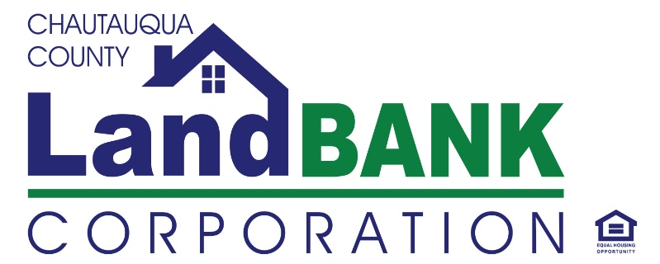

**BOARD MEETING SUMMARY**

**DATE: 02-14-24 LOCATION: GERACE OFFICE BLDG, ROOM 331, Mayville, NY**

**Attendees: Bob Scudder, Bonnie Strickland, Chuck Cornell, Diane Hannum, Mark Geise, John Hemmer, Lou Drago, Rebecca Meeder, Todd Hnityszyn**

**Absent:**

**Excused**: Shelley Lincoln, Hugh Butler

**Guests:**

**HIGHLIGHTS**

|  |  |
| --- | --- |
| **1** | **Welcome & Privilege of the Floor:** John H. The meeting was started once a quorum was present at 9:10 AM. |
| **2** | **Approval of Minutes:** The minutes of the December meeting were reviewed and approved, with a motion by and seconded by . January Meeting had been cancelled, so no minutes to review. |
| **3** | **Property Dispositions:**  Purchasers were approved for the following properties:  Property Acquisition/Disposition – Homes & Side Lots (G. Paradis)  29 No. Pangolin Dunkirk 79.12-1-7  67 Pearl St. Jamestown 387.12-5-24 & 25  532 Columbus Dunkirk (side lot) 79.19-1-21  **Donation Proposed – Vacant Lot**  Lakeshore Dr. E.79.12-2-3 (75x100 vacant lot)  As requested by the board, we will no longer redact the names of the proposed buyers. It was discussed placing a covenant on 29 North Pangolin to ensure owner occupancy. The Lakeshore Dr. E. donor will receive a donation receipt for her taxes. There was unanimous approval of the resolution by the board. |
| **4.** | **Financial Report:** The audit committee meet on Monday, the 12th, to address any inquiries regarding the audit**.** Our auditors meet with us via Zoom.The performance escrow fund audit revealed several long-standing cases that had previously gone unaddressed. Purchasers were sent multiple notifications without any response nor effort for a final inspection to demonstrate completion of the work, so the Performance escrow was reclassified as other income. The board accepted and approved the independent audit report, including financial statements and recommendations, for fiscal year 2023 prepared by Edward Bysiek, CPA, PLLC, which provided a clean and unmodified opinion. Good work by Jennifer on ensuring the internal controls that led to the clean audit. |
| **5** | **Legislative Updates:** The governor has proposed legislation to offer guidance following the Supreme Court decision regarding foreclosure surplus funds in New York State. However, the matter is still under discussion and legislative review and has not progressed further. The tax foreclosure moratorium was vetoed, leading to an upcoming auction. Currently, there are conflicting opinions on how the land bank or the county would approach valuation of the properties or pay any excess funds to the owner. The Land Bank will proceed with appraising all our properties.The board also discussed the idea of forming a collective group to request a meeting with our state representatives. This is to ensure they grasp the municipal perspective of Chautauqua County. |
| **6.** | **Board Training Compliance:** Gina & John H. reviewed the current standards forthe County’s Code of Ethics and the Board’s requirements to sign off on the **training** materials, and completion of the Financial Disclosures. Members in attendance signed off on the Code of Ethics training materials that were distributed via Email/Share file before the meeting. |
| **7** | **Program & Activity Updates:  Our upcoming preparations include our annual meeting next month, which will also involve the election of officers. The annual report will be completed by then. Demolition progress is picking up pace now that we have completed our initial 1st round of environmental reviews. It took around 3 1/2 months to complete the environmental review process. Now, with clear expectations, they are progressing to the 2nd batch and starting procurement for Batch #1.** The upcoming meeting will focus on collaborating with Habitat on new projects. CC PEG - Josiah from COI and Gina are Co-Chairs of the Housing Work Group. As one of the two priority projects tackled this past year, consultants are in the final stages of completing the housing study for the entire county. The release of the final report will be out soon.Also, **The Healthy Housing team went through a process this past year on creating an organizational development strategy to formalize that group, which engaged a diverse group to participate across varied nonprofits, public and private sector organizations.**Strategic planning was also discussed for the future of the county housing market and affordability issues. |
| **8** | **Meeting Schedule & Adjournment:** March 13th – Annual Meeting & Monthly Board- A motion was made by Lou D to adjourn, seconded by Mark G. and carried unanimously to end the meeting @10:25AM |

**Resolutions for Regular Meeting of**

**Chautauqua County Land Bank Corporation Board of Directors**

**February 14, 2024**

**Resolution # 02-14-24-01 Approving the FY- 2023 Annual Audit**

RESOLVED, that the Board of Directors of the Chautauqua County Land Bank Corporation hereby accept and approve the independent audit report, including financial statements and recommendations, for fiscal year 2023 prepared by Edward Bysiek, CPA, PLLC.

**Resolution # 02-14-24-02 Authorizing Transfer of Property**

RESOLVED, that the Chairman, Vice-Chairman, and Executive Director are each separately authorized to transfer the property to the prospective purchaser listed below and to their spouse, family members, and business partners, if applicable, or to their designated business entity, upon such terms and conditions negotiated and approved by legal counsel based on the proposals received and reviewed by the Board:

Property Address Property Tax ID # Purchaser

29 No. Pangolin St. Dunkirk 79.12-1-7 Scott A Thompson

67 Pearl Ave. Jamestown 387.12-5-24 Millie Ortiz & Hector Correa

532 Columbus Dunkirk (side lot) 79.19-1-21 Homayoun Ghaderi

AND RESOLVED, that the Chairman, Vice-Chairman, and Executive Director are each separately authorized to accept the property listed below as a donation valued at $15,000

Donation (Side Lot) Property Tax ID# Parcel Owner

Lakeshore Dr. East, Dunkirk 79.12-2-3 Pauline Newman