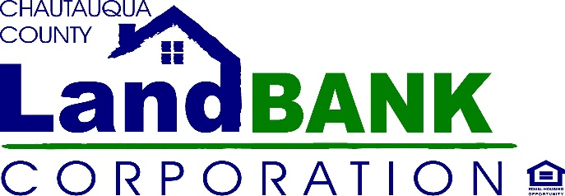

BOARD MEETING SUMMARY

DATE: August 11th, 2021
LOCATION: ERA Offices, 3rd Street, Jamestown NY

Attendees: John Hemmer, Hugh Butler, Taylor Scott, Bonnie Strickland, Charles Cornell, Diane Hannum, Louis Drago
Excused: Paul Whitford, Nicole May, Mark Geise, Rebecca Meeder
Absent:
Staff: Gina Paradis, Jennifer Cameron, Ariel Davis, Allison Carrow & Stephen Abdella, (Legal Counsel)
Guests: Shelly Lincoln

HIGHLIGHTS

1 | Opening After some technology and quorum delays, John H. opened the meeting at 9:25. The board welcomed guest Shelly Lincoln, a resident of Cherry Creek. Shelly thanked us for welcoming her at our meetings and for the work that the Land Bank does.
2 | Meeting Minutes: for Jun 2021 were approved with a motion by Hugh B. seconded by Chuck C. carried unanimously.
3 | Real Estate Data Presentation – Taylor Scott (Board Member & Commercial Real Estate Agent) Taylor led a discussion and demonstration to enlighten the board about the breath and depth of personal and parcel data that is available to real estate investors and speculators, and how data is used to drive decision-making in real estate investment. The Board discussed the extent to which personal data is extrapolated from a variety of sources, including social media, demographics, public records, etc. to paint a picture of potential seller disposition and real estate ripe for acquisition. Taylor presented some examples of real estate data platforms available to investors, and discussed the inadequacies of data in our county and the lack of access to technology for data driven housing and government services strategies. A discussion ensued regarding the proposed pilot project that would seek to utilize artificial intelligence for predictive modeling of pre-foreclosures. The Board’s predisposition is not to enter into the pilot based on a lack of confidence in the technology, the firm and the county’s ability to supply the data needed to drive the algorithms, and misgivings about the process and the optics of the approach. It was suggested that perhaps we first need to resolve our data compilation and management issues, and then search out a technology platform that provide similar analytics to support our intervention strategies. The Board appeared to be in agreement on this course of action. Taylor, Gina and legal counsel will discuss further and define a course of action with the firm proposing the pilot and next steps.
4 | Program Updates: Hands On Neighborhoods is halfway through its summer cleanup schedule. Next cleanup is scheduled for August 21st. Demolitions are slogging along, and Gina voiced a concern over the competitive bid process and the lack of bidders for recent work. Adjustments to the procurement policy may be proposed to allow for more diversity in bid competition.  The rehabs in Dunkirk and Jamestown are moving forward with bids being solicited for the exterior work on Prendergast, and the final architect renderings and RFPs due in a few weeks for the Dunkirk house. Construction materials are finally starting to come down in price, so we hope to move as quickly as possible to get the construction moving forward.  The rehab loan fund MOU is being finalized with HOME HQ this month, and should be funded and ready to market by the 4th quarter.  Much work is being done currently with regard to advocacy on the state and federal level, primarily with regard to funding of post-COVID housing initiatives and allocations for Land Banks through-out the country. hopefully more news to be shared on that in the September meeting.
6 | Board Development: Gina proposed some board development sessions and queried the board on their interest and preference for scheduling. A survey will be created and forwarded for individual responses since many different suggestions were made.
7 | Meetings: There are several members with conflicts on the standing meeting dates, and a request made to query the Board on changing our meeting schedule. Meetings have returned to face-to-face and the waiver has not been extended for the public meeting law that allowed boards such as the land banks to meet via Zoom. The meeting schedule will be incorporated into the Board survey to be distributed prior to our next meeting.
8 | Adjournment: Motioned by Chuck C. Seconded by Lou D. carried unanimously

