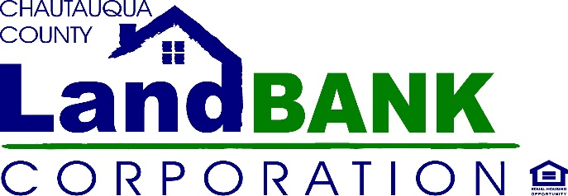

BOARD MEETING SUMMARY

DATE: June 16th, 2021
LOCATION: Zoom

Attendees: John Hemmer, Hugh Butler, Mark Geise, Taylor Scott, Bonnie Strickland, Charles Cornell, Diane Hannum, Rebecca Meeder, Louis Drago
Excused: Paul Whitford, Nicole May
Absent:
Staff: Gina Paradis, Jennifer Cameron, Ariel Davis, Allison Carrow & Stephen Abdella, (Legal Counsel)
Guests: Kim Meleen
HIGHLIGHTS

1 | Opening John H. opened the meeting at 8:08. The board quickly introduced themselves to Kim Meleen and Ariel Davis.
2 | Meeting Minutes: for May 2021 were approved motioned by Mark G. seconded by Chuck C. carried unanimously.
3 | Executive Session: Parcel Revenue Service: The Board discussed matters pertaining to potential engagement/legal contracts with the specified vendor. No action was planned to be taken.
4 | Demo and Side lot Acquisitions: Gina P. reviewed the circumstances of titles for demo, side lot, and rehabilitation properties. Currently, the county holds the titles of auction properties to be demolished in foreclosure judgement. In doing so, they incur approximately $56,000 in tax expenses annually until properties are transferred to the new owner after demolition, which can be two years or longer. Stephen A. brought forward a proposal from the county in which titles are transferred to the Landbank to optimize their tax exemption. The county would in turn be responsible for maintenance costs conservatively estimated by Gina P. at $32,000 annually for 50-60 properties. Several years ago, a resolution was passed that the Executive Director and Board Chair can accept properties on a yearly basis. Gina P. requested additional authorization to accept properties.  Clarification was provided that:  - The county could be requested to contribute 100% of maintenance costs  - Properties would be tax exempt immediately after transfer  - Tax exemption for the county would not begin until the next tax date and does not apply to school taxes  - A decision is preferred by July 1^{st,} as tax assessment roles are delegated then  Stephen A. will meet with the county and discuss:  - Profit sharing for developable properties  - County reacquisition of side lots with extended vacancies  - A yearly contribution from the County to Landbank to cover maintenance costs (which will help Landbank leverage resources for grant applications)  After discussing with the county, a decision will be negotiated between the Executive Director, the Chair & Vice Chair, with legal counsel.
5 | Finance Update: Jennifer C. provided a review of the Year-to-date Balance sheet and P&L. The largest Liabilities are performance bonds ranging from $2,500-$7,500. Jennifer and Gina have been working with the legal team to contact the purchasers and decide whether to retain the bonds as income or rebate to the owner. Insurance policies were purchased  - Middle Rroad property: $30,000 cash value on property for $309/year  - H.O.N. Trailer: a year of insurance for $175/year  - Tools and Equipment: $20,000 of equipment for $192/year  - D&O (Directors and Officers) policy for $895/year  Jennifer and Gina believe this insurance coverage will provide adequate protection against potential losses/lawsuits in the near term. Additional risk mitigation will continue to be assessed.
6 | Program Update: Gina P. shared that the sale Hideaway Bay, will not close until financing is in place, anticipated closing is 9/10/21, the day after one of their (potential but confident) grants kick in. Hands On Neighborhoods and CPTED are of high priority in our weekly activities.
7 | Meetings: To be continued on Zoom until we hear that our face-to-face meetings waiver is revoked.  Monthly Meetings: July 14th, August 11th, September 8th
8 | Adjournment: Motioned by Chuck C. Seconded by Mark G. carried unanimously

