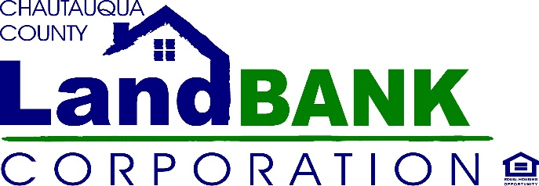

BOARD MEETING SUMMARY

DATE: September 8, 2021
LOCATION: Fredonia Tech Incubator, Central Ave, Dunkirk NY

Attendees: Hugh Butler, Taylor Scott, Bonnie Strickland, Charles Cornell, Louis Drago, Mark Geise, Rebecca Meeder, Paul Whitford
Excused: Nicole May, Diane Hannum, John Hemmer,
Absent:
Staff: Gina Paradis, Jennifer Cameron, Allison Carrow (Legal Counsel)
Guests: none

HIGHLIGHTS

1 | Opening: Mark G ran the meeting in John H.’s absence. Mark opened the meeting at 9:08 once quorum was established. No guests were present so there was no comments during Privilege of the Floor.
2 | Meeting Minutes: for Aug 2021 were approved with a motion by Chuck C. seconded by Paul W., carried unanimously.
3 | Financial: Jen C. guided the Board through a review of the Year to Date Profit & Loss. Some discussion ensued regarding Salvage and the limited profits we have shown by our rental of the space at Dart Airport. We will pull out of there in October and explore other avenues of marketing our goods. Revenues from the sponsorship marketing for Hands On Neighborhoods was highlighted as the first program where the Land Bank has been successfully able to generate sponsorships and donations. These revenues will be directed back into the program as it expands.
4 | Program Updates: Hands On Neighborhoods – Clean up events are almost over for this season. Next cleanup is scheduled for Sept. 25th. Demolitions -continuing to slowly move; Gina reiterated her concern over the competitive bid process and the lack of bidders for recent work. Adjustments to the procurement policy may be proposed to allow for more diversity in bid competition.  The rehabs in Dunkirk and Jamestown are moving forward with bids being solicited for the exterior work on Prendergast, and the final architect renderings and RFPs due in a few weeks for the Dunkirk house. Construction materials are finally starting to come down in price, so we hope to move as quickly as possible to get the construction moving forward.  The rehab loan fund MOU is being finalized with HOME HQ this month, and should be funded and ready to market by the 4th quarter.  Gina shared an overview of the Federal bills and advocacy around funding legislation in the federal government. Specifically, with regards to HRH 216 Communities Left Behind, which the Land Bank Assoc. was very successful at advocating with Senator Gillibrand, who offered to cosponsor the Bill in the Senate, but Gary Peters (MI) beat her to the punch. NHIA (Neighborhood Homes Investment Act) appears to be in the best position of all the legislation, and Senator Schumer has supported it. The National Land Banks Network Act, which promotes a National Network Infrastructure and funding for landbanks nationally is on pause currently.
6 | Board Survey: Gina prepared a survey and forwarded for individual responses since many different suggestions were made regarding meeting schedule and board development. Once everyone has participated, the survey results shall be shared. There was some discussion that the link wasn’t easily accessible, so Gina will send a WORD version out as an alternative for completion.
7 | Meetings: October – scheduled for Mayville on 10/13. November & December may resume as Zoom meetings pending the waiver extension on public meetings from Albany.
8 | Adjournment: Motioned by Chuck C. Seconded by Paul W., carried unanimously

