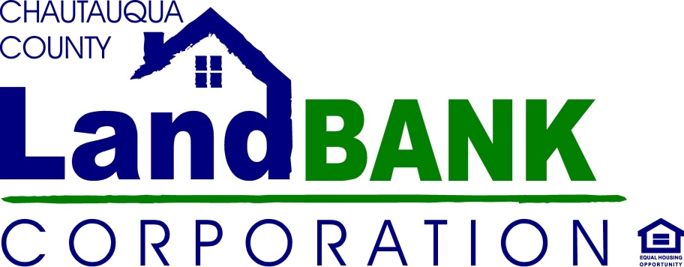
SALES 4 REHAB APPLICATION

Name __________________________________________________________________________
Address _______________________________ City/State/Zip _____________________________
Phone ________________________________ Email ____________________________________

Race: White American Indian/Alaskan Native Black, not of Hispanic origin

Asian/Pacific Islander Other__________________________

Ethnicity: Hispanic/Latino Not Hispanic/Latino Prefer not to say

I have read and agree to the policies and terms of sale for the Sales 4 Rehab Program. By my signature below I give consent for a confidential credit report check and financial disclosure. All information will be restricted and held in confidence by the Chautauqua County Land Bank.
______________________________________Signed ____________________________Date
______________________________________Printed Name ______________ Last 4 digits -SSI #

Continued on next page…
Occupation________________________________ Employer __________________________________
Years at current place of employment __________ Years in Occupation __________
Current Salary $__________________ per hour/week/annum (please circle)
Income verification provided:
- Tax Return
- W2
- Pay Stub
Please attach a copy of the above with your application.

Do you believe you qualify for low-to-moderate income programs? (Your household income must be below $49,050 for a family of 2, $ 55,350 for a family of 3, and $61,500 for a family of 4. Data according to https://www.ushousingdata.com/income-limits/chautauqua-county-ny)
(circle appropriate answer) Yes No Not Sure

If you qualify, are you interested in home buying or rehab assistance program information?
(circle appropriate answer) Yes No

How many people will live in your house post-renovation?______________________________________

How many:
Children 5 and under? __________________________________
Children ages 6 to 12? __________________________________
Children ages 12 to 18? __________________________________
Adults under 62? __________________________________
Adults over 62? __________________________________

I hereby authorize the Chautauqua County Land Bank to perform a bank verification to ensure that I have the financial wherewithal to commit to the proposed reinvestment in this property.
Signature Date___________________________

Financial Institution: ___________________________ Phone: ________________________________
Financial Institution: ___________________________ Phone: ________________________________

