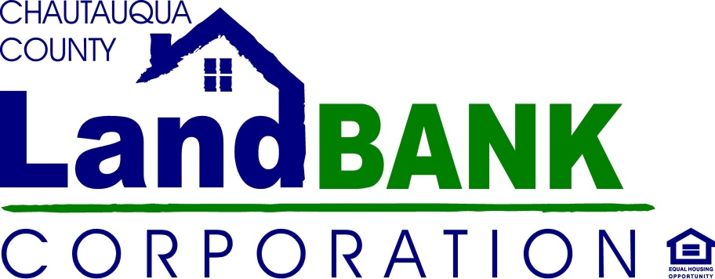
REHABS 4 SALE
APPLICATION

Name __________________________________________________________________________
Address _______________________________ City/State/Zip ____________________________
Phone ________________________________Email ____________________________________
Land Bank Property Address _________________________________________________________

I have read and agree to the policies and terms of sale for the Rehabs 4 Sale Program. By my signature below I give consent for a confidential credit report check and financial disclosure. All information will be restricted and held in confidence by the Chautauqua County Land Bank.
______________________________________Signed ____________________________Date
______________________________________Printed Name ______________ Last 4 digits -SSI #

Occupation________________________________ Employer __________________________________
Years at current place of employment __________ Years in Occupation __________
Current Salary $__________________ per hour/week/annum (please circle)

Income verification provided:
- Tax Return
- W2
- Pay Stub
Please attach a copy of the above with your application.

Do you believe you qualify for low-to-moderate income programs? (Your household income must be below $36,250 for a family of 2, $ 40,800 for a family of 3, and $45,300 for a family of 4)
(circle appropriate answer)
Yes No Not Sure

If you qualify, are you interested in home buying or rehab assistance program information?
(circle appropriate answer)
Yes No

I hereby authorize the Chautauqua County Land Bank to perform a bank verification to ensure that I have the financial wherewithal to commit to the proposed reinvestment in this property.
Signature Date___________________________
Financial Institution: ___________________________
Phone: _______________________________________

Financial Institution: ___________________________
Phone: ______________________________________

