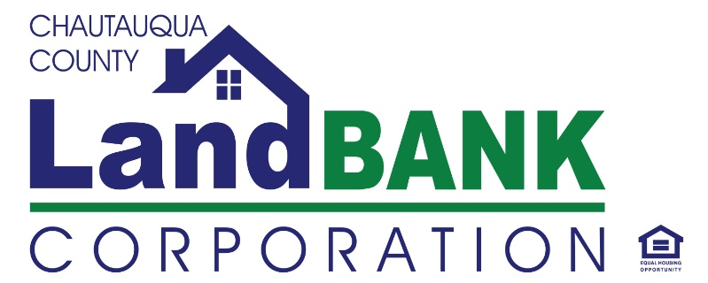

**BOARD MEETING SUMMARY**

**DATE: 08-14-2024** **LOCATION: GERACE OFFICE BLDG, ROOM 331, Mayville, NY**

**Attendees:** Bob Scudder, Mark Geise, John Hemmer, Chuck Cornell, Bonnie Rae Strickland, Lou Drago, Shelly Lincoln, Hugh Butler

Staff: Gina Paradis, Todd Thomas (contracted), Reuben Hernandez, Jennifer Cameron

**Absent:**  Rebecca Meeder

**Excused**: Diane Hannum

**Guests:** No guest

**HIGHLIGHTS**

|  |  |
| --- | --- |
| **1** | **Welcome & Privilege of the Floor:**  Mark Geise welcomed everyone and started the meeting at 9:09 |
| **2** | **Approval of Minutes:** Review/approval of the minutes of the June meeting were motioned by Bob. S and 2nd by Shelly. L |
| **3.** | **Property Dispositions: The Board reviewed the property proposals and made the following decisions:**  **434 Bucknor St (lot) in Dunkirk**  **712 Grant St (lot )in Dunkirk**  **17-19 Main St (lot) in Sinclairville.**  **It was noted that for both Dunkirk lots, neighboring residents expressed interest prior to the demolition, and both lots would allow for yard expansions since they are not suitable for building. Regarding the Sinclairville lots, donation back to the village was accepted via Resolution at their Town Council meeting in June. They will be taking title and responsibility for maintenance,** thereby freeing us from that responsibility and cost.  **This motion was made by John H. and seconded by Bob S.** |
| **4.** | **Financial Report: In reference to the financial report, it was noted that we are steadily spending down our LBI grant, once we achieve 75% disbursed, we will be invited to seek additional grant funding from the surplus of that funding year. Demolition expenses has resulted in an over-projection that has exceeded the grant funding by approximately $700,000; meaning there are more demos in the queue to justify the additional funding request. Jennifer C. presented the Profit & Loss statement, in which several points concerning the expenses related to mowing were discussed. Additionally, it was brought up that from 2021 to 2023, we acquired over 100 side lots; contributing to the significant increase in expenses.** |
| **5.** | **Program & Activity Updates:** Gina P. provided an overview of current operations and activities, and mentioned that she is still working on the strategic plan. She is still reviewing the comments regarding the mission statement and vision, and will be drafting an Action Plan for review at the September meeting. We are continuing to explore alternative methods for property acquisition. Demolition reporting has taken a priority, both with the City of Jamestown and HCR, and we are facing challenges in hiring MWBE contractors in Chautauqua County due to a lack of certified business owners locally and the availability of others. Several of our special projects are facing an obstacle due to NYS historic preservation. Although we are not forbidden to move forward on those projects, additional consultation and efforts and reporting are necessary to satisfy the state.  It was discussed that the Town of Sheridan has asked whether The Land Bank has funds available to address the burnt-down Pawn Shop, a potential brownfield, and Gina P reported that although the Land Bank’s assistance was offered multiple times with feasible strategies, it was not accepted, and now there is no funding available through our current grant, at least until our next funding round. Some board members expressed concerns about acquiring the property. Others felt that we should acquire if available at the tax foreclosure and remarket the property post-demo. Gina P will work on securing a Phase 1 environmental study to assess the risk, and set up a meeting with the Town Supervisor and attorney to discuss.  Fortunately, our other special projects on Middle Rd and Temple St in Dunkirk are progressing well and are nearing completion. The emergency or supportive housing project, located on 4th St in Jamestown has been fully lead encapsulated, cleaned, and boarded up, making it much more marketing-friendly, and Gina has reached out to both public and private housing providers who may have interest in developing it. The exterior work on our property at 1144 Prendergast is almost completed and we are ready to complete basic interior renovations.  We had two professional development opportunities this year, one in Oswego in collaboration with the NY Conference of Mayors, attended by Gina, Bonnie and Reuben and another in West Virginia, attended by Bonnie and Reuben. The W. Va. Training represents a national cohort of rural land banks who will gather and share best practices, lessons learned, challenges faced, etc. Bonnie and Reuben were able to participate at no cost, as part of the Allegany Land Bank’s scholarship.  The Board also discussed the potential of sharing a staff member with Habitat with Humanity. More info will be discussed on this Shared Services proposal in September.  Legal updates included the new requirement that the Land Bank Board meetings will now be accessible to the public via live streaming. The video recording will act as a transcript, while the meeting summary will continue to suffice for public summation. |
| **6.** | **Meeting Schedule & Adjournment:** TheSeptember monthly meeting was moved to 9/18/2024 instead of 9/11/2024 –A motion was made by Hugh to adjourn, seconded by Bob S. and carried unanimously to end the meeting @ 9:57 AM |

**Resolutions for Regular Meeting of Chautauqua County Land Bank Corporation Board of Directors; August 14, 2024**

**Resolution # 08-14-24-01 Authorizing Transfer of Property**

RESOLVED, that the Chairman, Vice-Chairman, and Executive Director are each separately authorized to transfer the property to the prospective purchaser listed below and to their spouse, family members, and business partners, if applicable, or to their designated business entity, upon such terms and conditions negotiated and approved by legal counsel based on the proposals received and reviewed by the Board:

Property Address Property Tax ID # Purchaser

712 Grant Ave, Dunkirk 79.19-4-54 Kelly Hutton

434 Bucknor Ave, Dunkirk 79.20-5-81 Gerald & Linda Rafan

17-19 Main St, Sinclairville 251.13-1-18,19, 20 Village of Sinclairville