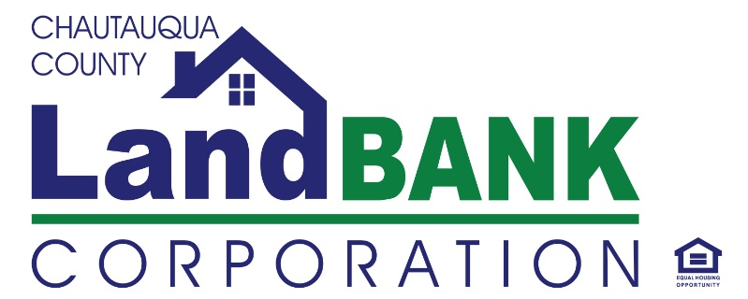

**BOARD MEETING SUMMARY**

**DATE: 05-8-2024** **LOCATION: GERACE OFFICE BLDG, ROOM 331, Mayville, NY**

**Attendees: Bob Scudder, Bonnie Strickland, Chuck Cornell, Diane Hannum, Mark Geise, John Hemmer, Hugh Butler, Todd Hnatyszyn**

**Absent:**  **Rebecca Meeder**

**Excused**: **Shelley Lincoln, Lou Drago**

**Guests:**

**HIGHLIGHTS**

|  |  |
| --- | --- |
| **1** | **Welcome & Privilege of the Floor:** Mark G**.** The meeting was started once a quorum was present at 9:00AM. |
| **2** | **Approval of Minutes:** The minutes of the February and March meeting were reviewed and approved, with a motion by and seconded by. (The April meeting was cancelled) |
| **3.** | **Property Dispositions:**  Purchasers were approved for the following properties:  Property Disposition – Side Lots & Middle Road - Special Project  94 Liberty Street, Jamestown (Side lot)  71 Middle Road, Dunkirk (home)  (Attachment 2, Resolution 05-08-24-0  The Board discussed the related issues with the homeless encampment at 94 Liberty Street Lot. The proposed buyer has offered to take on the responsibility of keeping the lot maintained, free of debris and unauthorized activities until the deed is transferred. They plan to build it out as a landscaped parking area with electric charging station in the future. The proposal was accepted.  Gina P provided an over view of 71 Middle Rd, a donation from Lakeshore Savings Bank secured before COVID. The property was initially funded by OAG for low-income buyers, with a preference for members of the BIPOC community. The Rehab project costs tripled after COVID, resulting in a much delayed timeline and potential for significant financial loss. Additional grant funding was secured to help fill some gaps, and the Land Bank hopes to break-even or take a small loss. A family qualified through Home Headquarters and fits the demographic sought by the grant funder. There was a motion for Resolution 05-08-24-01 by Bob and seconded by Hugh. |
| **4.** | **Financial Report:** Two documents were distributed for the financial report: the first-quarter report and the preliminary statement for April. During the discussion, it was mentioned that OAG Funds were finally spent down due to expenses related to 71 Middle Rd. Additionally, HCR funding was used to support administrative salaries and capital funding, and Commercial Demo funding was funneled in April. Special projects were discussed, including stabilization at Prendergast, Middle Rd, East 4th St, School 10, and Fairmount. IT expenses were high in April due to the annual renewal of software licenses. |
| **5.** | **Program & Activity Updates:** Foreclosure & auction updates Chautauqua County has announced that there will be no Tax Foreclosure Auction this summer, following new laws implemented by the governor on April 20th. Amendments are being considered currently to rectify some significant hurdles posed by the Governor’s guidelines. Turning properties over to the Land Bank may become risky/problematic. Going forward, it has been emphasized that appraisals for each property must be carried out to avoid potential lawsuits, including on properties destined for demolition. Gina reviewed other potential mitigation strategies around the changes to the foreclosure law and procedures, but reinforced the need to discuss as a board, the changing environment in which the Land Bank operates and contingency strategies for making future impact while remaining sustainable.  A sustainability committee was suggested as an ad-hoc solution to explore how raise funds through potential revenue producing activities and fundraising efforts or partnerships with other organizations. New grants are available to create new housing and implement a developer fee. The board retreat will cover discussions on these topics and review of our mission statement. The Conference of Mayors summer conference will be held in July in Oswego, with a Land Bank tract and extra day for our NYS Land Bank Association Summit. Gina, Reuben and Bonnie will attend. Bonnie and Reuben will also attend the Rural Land Bank Learning Exchange, hosted by the Center for Community Progress in W. VA. The Vacant Properties Conference will be held in October in St. Louis, but we are unsure whether we will be attending that.  It was suggested that Gina send out a Doodle poll for dates to hold a Board retreat, and consensus was that a mid-week afternoon would best suit the members. |
| **6.** | **Meeting Schedule & Adjournment:** June 12th – Annual Meeting & Monthly Board- A motion was made by Hugh to adjourn, seconded by BobS. and carried unanimously to end the meeting @10:00AM |

**Resolutions for Regular Meeting of Chautauqua County Land Bank Corporation Board of Directors**

**May 8, 2024**

**Resolution # 05-8-24-01 Authorizing Transfer of Property**

RESOLVED, that the Chairman, Vice-Chairman, and Executive Director are each separately authorized to transfer the property to the prospective purchaser listed below and to their spouse, family members, and business partners, if applicable, or to their designated business entity, upon such terms and conditions negotiated and approved by legal counsel based on the proposals received and reviewed by the Board:

Property Address Property Tax ID # Purchaser

94 Liberty St Jamestown (Lot) 387.26-1-47 Elliott Raimondo

71 Middle Road, Dunkirk 79.12-4-61 Rey and Juangeli Davilo