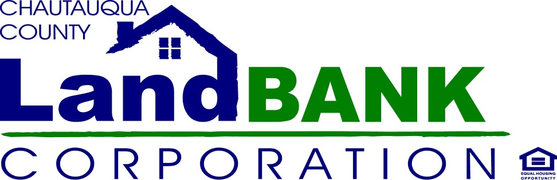

Introduction & Scope of Work: Request for Quote/Qualifications- Property Clean Out Services

The Chautauqua County Land Bank Corporation ("CCLBC", or "Land Bank") invites the submission of quotations for property clean out services. The majority of the Land Bank properties are acquired through the tax foreclosure process. Examples of current Land Bank properties are listed in Exhibit A of this document. Services would include removing trash and other debris from the property (interior and exterior), hauling or disposal, basic sweeping out and wiping down of surfaces, and miscellaneous services needed to ensure the property is clean and safe. A check list is provided in Exhibit B. Selected contractors shall document completed work by providing an invoice listing each property and service provided, hours worked, and number of employees on the job along with a copy of the receipt(s) for any materials/services purchased, to the Program Specialist, Jennifer Cameron.

In the event a valid complaint is received by a neighbor, municipality or other interested party the contractor shall have forty-eight (48) to remedy the situation. CCLBC is looking for pricing information in Exhibit C. Your firm is invited to quote on properties located in northern Chautauqua county, southern Chautauqua county or both.

Please provide an overview of your services, practices and rates in the section provided, and include the requested references.

About CCLBC

The CCLBC was formed by Chautauqua County (2011) as a not-for-profit corporation, operating under state authority (2012), with the mission to minimize the negative impacts that substandard properties and structures have on communities, thereby stabilizing neighborhoods and Main Streets. The CCLBC controls and manages strategically selected dilapidated residential and commercial properties, granted to the agency by the County from the tax foreclosure process. We acquire, manage and transfer these properties, under specific criteria, to remove blight and foster reinvestment in our county's neighborhoods.

Terms and Conditions

All contractors must meet the following minimum criteria:

- Legally licensed ( or proof of insurance & worker’s comp)in New York State;
- Prior experience in property maintenance or cleaning services, and include references from at least three (3) government or business clients within the past five (5) years;
- Use of responsible and licensed subcontractors;
- Satisfactory bank reference;
- Commercial General Liability and Property Damage Insurance in the amount of $1 Million and evidence of automobile liability and workers compensation insurance with a deductible not exceeding $10,000. The Land Bank must be named as additional insured by the contracted firm; and sent a certificate upon approval of contract
- Transparent and effective system for tracking costs.

Contractors and sub-contractors may not participate if they have a recent history of the following:

- Local, State and Federal tax arrears;
- Labor violations;
- Arson, fraud, bribery or grand larceny conviction or pending case;
- A record of substantial building code violations or limitations on property controlled by the contractor of by any entity or individual that comprises the contracting entity;
- Formal debarment or suspension from entering into contracts with any governmental agency or other notifications or ineligibility for or prohibition against bidding or proposing on government contracts; and
- Denial of a contract based on any obligation to, or unsatisfied judgment or lien held by, a governmental agency.

Exhibit A

Examples of Properties Owned by the Chautauqua County Land Bank Corporation

North County:

721 Deer St., Dunkirk
96 W. Main St., Westfield
74 Gardner St., Fredonia

South County:

222 Price St., Jamestown
26 Vega St., Jamestown
115 Price St., Jamestown

Properties will vary in terms of the condition and volume of debris. All properties will be secured by the Land Bank prior to entry by the Clean-out company.

Exhibit B

Work Completed
Property Clean-out
Sticker Items to be salvaged/stored
Order Roll-off /dumpster /dump trailer as needed
Bag/haul disposal items to truck/dumpster
Record items of hazard waste or special disposal
Haul disposals to land fill
Record Land Fill weights & retain receipts
Remove salvage items to agreed storage facility
Sweep/vacuum property
Clean surfaces (counters, window sills,etc)
Photograph salvage items and inventory
Submit Invoice with Check list, photos and Receipts to CCLBC
CLEAN-OUT EXPENSES SUBTOTAL
Mics. Expenses
TOTAL EXPENSES BILLED TO LAND BANK
ATTACH ALL RECEIPTS FOR REIMBURSEMENT

Exhibit C

Please complete the pricing information below.

RATE Per hour | Employee Level or Activity
e.g. $ x/hr. | cleaner
e.g. $ x/hr. | supervisor

Additional Fees/Services | Estimated charge or mark-up
e.g. Mileage over 20 mi. | $./mi.
e.g. Dumpster rental | x% mark-up

BIDDER: ____________________________________________________________________________

ADDRESS:___________________________________________________________________________
OWNER: ___________________________________________________________________________
PHONE NUMBER:_____________________________________________________________________
INSURANCE CARRIER & POLICY NUMBER: _____________________________________________________________________________________

ANY ADDITIONAL INFORMATION: ________________________________________________________

_____________________________________________________________________________________

Email quotations to Jennifer Cameron at jcameron@chautauqualandbank.org or call 716-969-7843 with questions about this request. All bids are due back for review by June15, 2017

